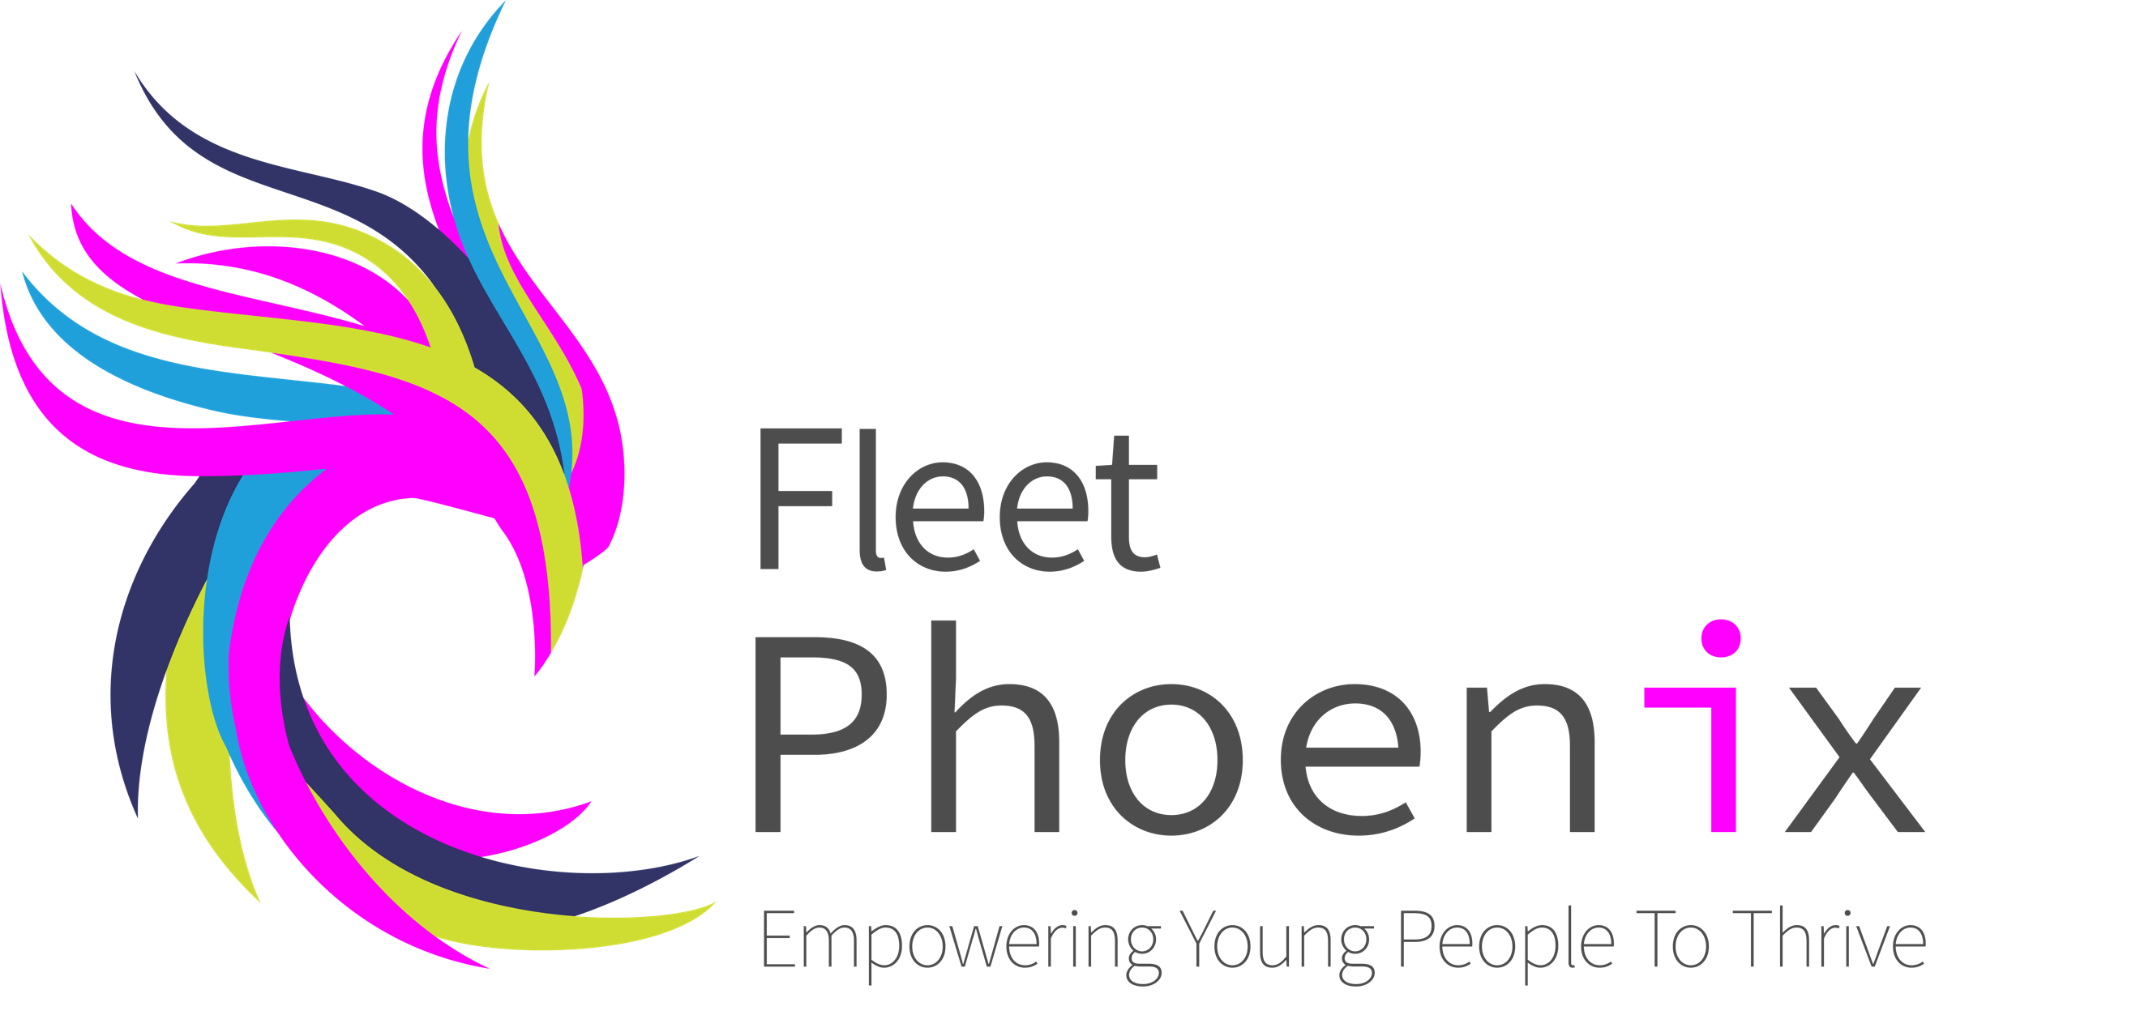

OFFICE ONLY:
Date received:

Fleet Phoenix
RADA – Resilience against Domestic Abuse

Weekly - Mondays 4pm - 5.30pm

Resilience against Domestic Abuse (RADA) is a free session for children of junior school age, who have been or are witness to domestic abuse in the home.
​
This project works on an early intervention model with an appreciation of the child's life situations.
​
The project will offer children a safe, warm welcoming place, which offers them space, time, and freedom to:
- Have time out.
- Play and learn.
- Feel supported and understood.
- To express themselves in a safe environment.
- Understand their environment and what they are witnessing.
- Develop strong & effective relationships with the Youth Work team who will be able to offer ongoing support.
​
This project actively seeks referrals from any supporting agencies and family members.

About the person making the referral
Name
Organisation
Contact details - email & phone number

Name of young person
(Please complete a separate form for each young person)
Address | Postcode:
Telephone No Home
Date of Birth
Gender
School Year
Any School attendance issues?
School & named person contact details i.e., form tutor
Name of GP & Surgery | Phone no:
Are there any other professional workings with you?

If Yes - Name, service & contacts please
Please use reverse if more than one is involved.
Housing situation (Who lives in the home and type of housing social or private)
Health issues to be aware of:
(physical and/or mental)
Disabilities to be aware of:
Learning difficulties to be aware of:
Has the client’s parent / guardian agreed for their information to be shared with Fleet Phoenix?
Parent/Guardian name:
Parent/Guardian address if different from client
Parent/ Guardian contact details: | Email-  Landline-  Mobile-
DA History (please give us some background to the DA within the family and the impact on the young person: (what they have witnessed)
Perpetrator/s relationship to the child:
Does the perpetrator have contact with the young person?
Is there any continuing risk to the young person?
Please give any history with Children’s Services i.e., CIN plan, CP Plan, and level of intervention from Childrens Services.
Please give us as much information as you can about the issue you are referring the young person to us for including any work previously undertaken, family situation/issues & anything you believe to be impacting on the young person’s life.
Some insight into their behaviour, character & family dynamics would be useful.
Please also forward any formal paperwork you have for this young person along with the completed form to: Charlotte.tickner@fleetphoenix.co.uk

Let’s talk about your privacy:

Fleet Phoenix would like your permission to retain your details on our Data Base. This information is held confidentially and only the right people have access to your information.

We would like your consent for the following:

Consent to retain your information: Yes/No (This is a highly secure, cloud-based Data Base).

Consent to sharing information: Yes/No (This will only ever be done in your best interests. We never share your information for marketing purpose or with anyone that is not connected to your life/issues).

Remember……………

As an organisation we must keep your information safe and is protected by the General Data Protection Regulation (GDPR) 2016.

You have the right to withdraw your consent anytime. We will keep your information all the time you have the right to our support and will contact you when you are 25 to ask if you wish us to keep information archived.
You can change your mind who we can share information with at any time. If you require a copy of our Data Protection Policy, please contact the Fleet Phoenix main office - 01252 812308 or charlotte.tickner@fleetphoenix.co.uk

Date:

Signed (Client):

Notes:

